History of Large Language Models

- Encoder/Decoder:
- Consider this sentence ‘I love India’, each word will pass through the encoder, gets process inside it and finally when last word will enter and come out, it will create a compressed representation of the whole sentence (context vector). This context vector then will pass to the decoder.
- Inside encoder and decoder, there can be anything, RNN, LSTM or GRU.
- The problem with this model was, it was giving proper output on short sentence, but on long sentences, the quality of output deteriorates. This happens bcz it losses the initial information as the sentence becomes long.
- To solve this issue, Attention mechanism was introduced.

- Endcoder/Decoder:

  - Encoder:
    - Think of it like a reader. Consider the sentence ‘I love India’, it reads the whole sentence word by word and after the last word, it gives a context vector (A summary of entire sentence.

  - Decoder:
    - Think of it like a translator. It takes the context vector as an input, from the encoder.
    - It uses this information- summary of the entire sentence, to generate the translated sentence, one word at a time.

  - Problem:
    - If a sentence is too long, the context vector starts to lose the initial informations and the decoder is not able to generate the proper output.
    - This is bcz the whole output is depending on one context vector.
    - To fix this, researchers introduced attention mechanism, where instead of relying on just one vector, the decoder can look back at the entire input sentence as needed.
See the visual diagram of encoder/decoder:
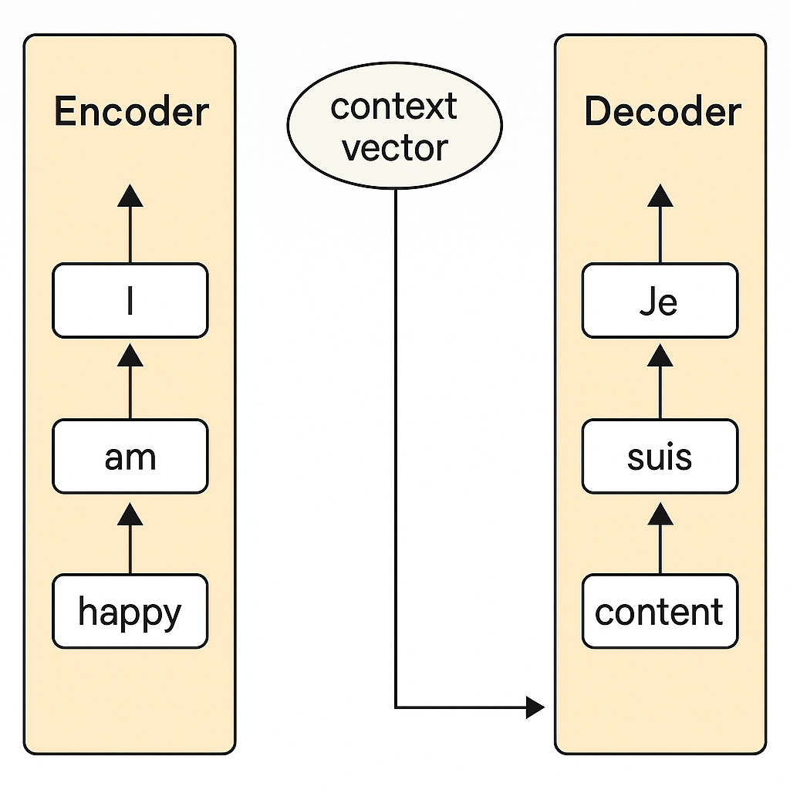

- Attention Mechanism:
The problem with encoder/decoder was that, it was unable to work properly on large sentences as Decoder’s process was only depended on one context vector. So, to solve this problem, Attention mechanism came into play.

  - Encoder:
- Encoder still does the same process here, but it doesn’t give us a context vector. But we know that inside encoder, there can be RNN, LSTM or GRU. So after each word, it will have hidden state and cell state -remember this.

  - Decoder:
- What decoder does is, it has a access to every hidden state and cell state of the encoder.
- All the hidden states and cell states is passed to the Attention layer and for giving output, decoder decides, based on which particular state, it should give the output.

See the below diagram.
Input: The dog chased the cat
↓ ↓ ↓ ↓ ↓
h1 h2 h3 h4 h5 ← Encoder hidden states
When generating "बिल्ली", the decoder focuses more on h5 ("cat")
Attention Weights → more weight on "cat"
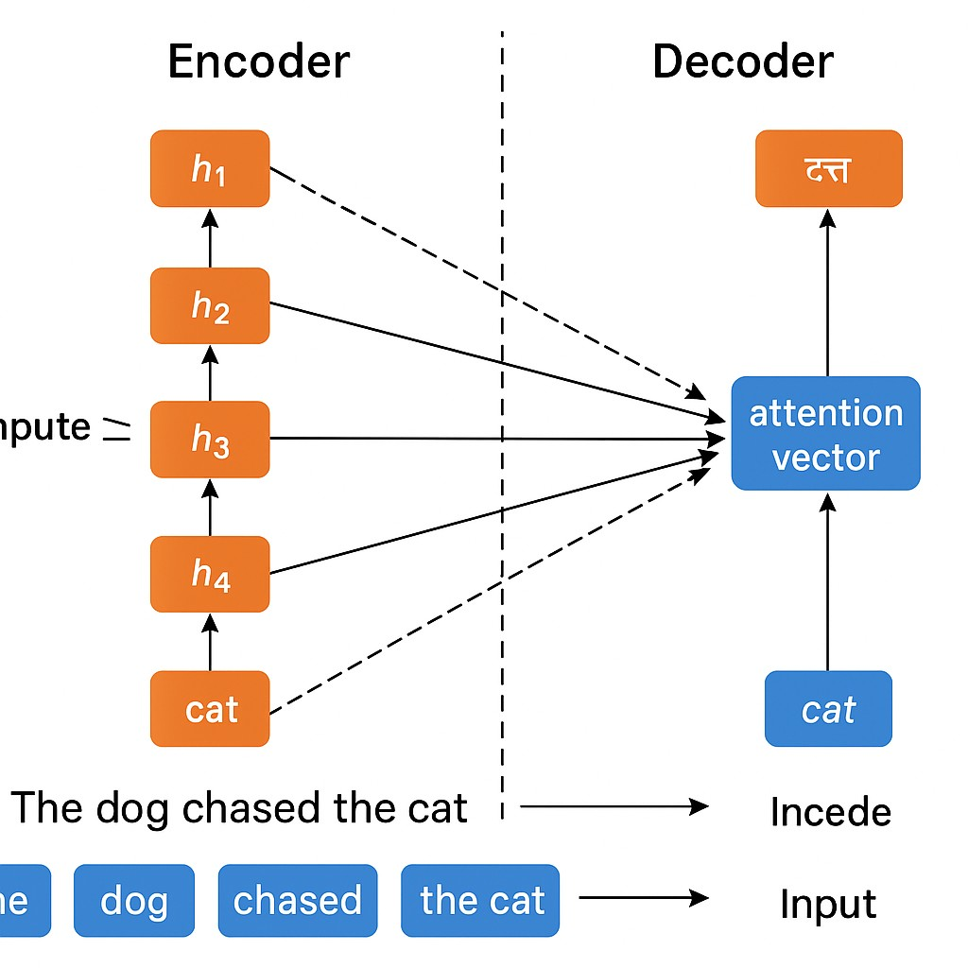
- Transformers:
- Attention Mechanism was working well and was giving proper outputs, but the only problem with it was, it was very computationally expensive.
- See, the decoder here, to output a particular word, needs to calculate the similarity with all the words present in a sentence. This requires high computation.
- To solve this problem, Transformer were introduced.
- Transformers removed RNN/LSTM/GRU from the encoder/decoder and introduces ‘Self attention’, which rather than processing one word at a time, process all the words parallely.
- This reduced the computional complexity and also training time to a large extent.
Structure of a Transformer (Simplified)
Just like encoder-decoder models, Transformers also have:
- Encoder: Understands the input
- Decoder: Generates the output
But inside each encoder and decoder block, you’ll find:
- Multi-head Attention: Multiple attention mechanism, each focusing on different aspects of a sentence.
- Feedforward layers
- Positional Encoding (adds word order info):
  - Since Transformers don’t process words one by one, they don’t know word order.
  - So we add special signals (vectors) to tell the model the position of each word.
- Layer Normalization
And multiple such blocks are stacked together (like layers in a cake).

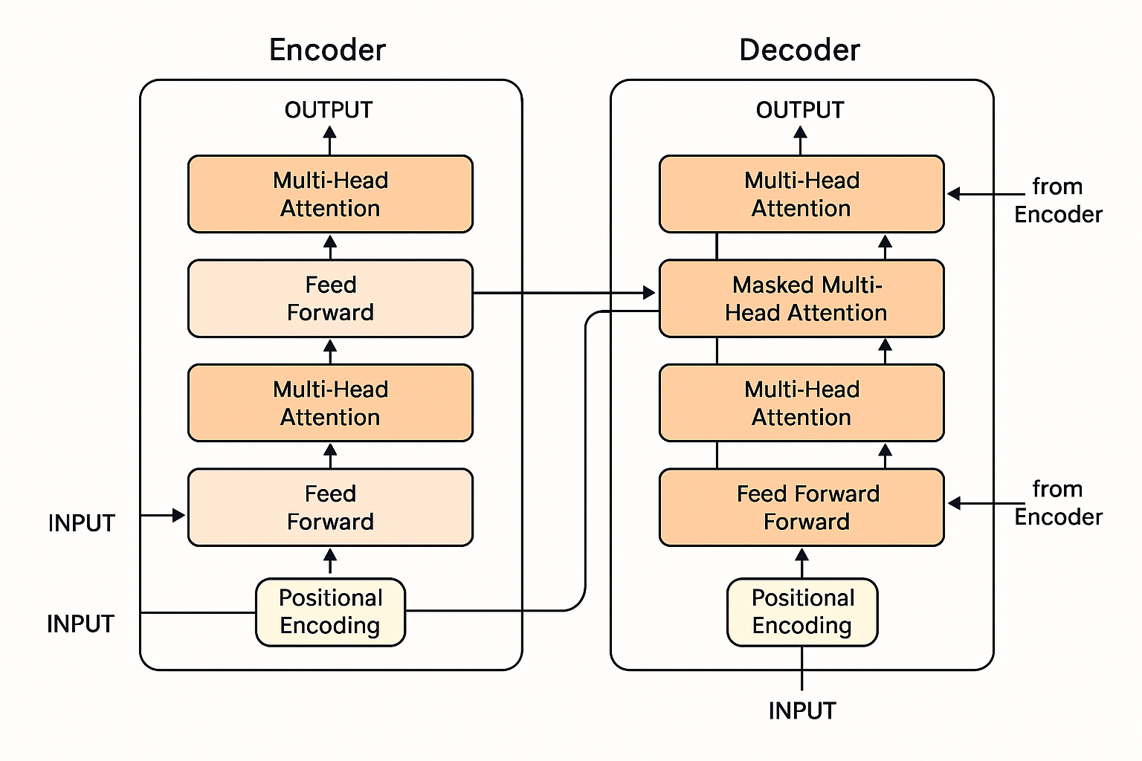

- Transfer learning:
  - Transformers solved all the problems faced till now, but it was not easy for everyone to create its own transformer. Below are some of the reasons.
    - It requires large amount of hardwares like GPUs with very large computatiional powers. Hence, it is very very costly.
    - It requires high training time. Ofcourse very less than Encoder/Decoder and Attention mechanism, but still very hign.
    - Most important, it requires large amount to data to train it. For example, for just a small sentiment analysis, it requires 1 lakh, 2 lakh etc. But not everyone is having such large amount of data.
  - Hence, because of these issues, not everyone was able to use this powerful technology. To solve this issue, Transfer learning came into play.
  - But untill now, transfer learning was not available on NLP models bcz of following reasons.
    - Task specific models: Models of NPL were task specific like, NER, POS tagging, sentiment analysis, machine translation etc… So, it wasn’t possible to fine tunn these task specific models to some other purpose models
- So there was not any specific model, which can be fine tuned to build other models.
- The solution was found which was a model of Machine Translation. This model can work in fine tuning. But then a new problem arrised, large amount of labled data. For example, English to Gujarati translation requires English sentence and its labeled Gujarati translation. This was very tedious task.

- But then in 2018, a Research paper was released, were instead of using machine translating model to fiinetune, Language Modelling model was used.

- Language modelling is model which predicts the next word.

- It was found that these models learn many thing while predicting the next word, like the essense of the sentence, grammar, meaning etc…

- Not only this, some very good models also captures great patterns from the sentence. For example, in a sentence ‘The movie was exceptionally good but the acting was ________. It will immediately predict a negative word bcz I has learned the pattern that if in a sentence, ‘but’ word comes and before it, praising words are used, it means now something negative will be talked about.

- Also, the most important thing was, language modelling, is Unsupervised learning, it don’t require labelled data. How?

- See, we need labels, but they are not created. We use the next word as a label. For example, ‘India is a beautiful country’, here, labels are created using the sentence only. See the table below
Word | Label
India | is
India is | a
India is a | beautiful
India is a beautiful | country

- Hence it is an unsupervised task (or more precisely, self supervised).

This gave birth to ChatGpt. See, GPT is a model and ChatGpt is an application developed using GPT model. GPT model was trained for language modelling only.
Let’s not dive deep into the journey of ChatGpt bcz we only want the general undestanding of some concepts, which we got.
In next session, we will dive deeper into encoder/decoder.

